LHP Founding Email (March 05, 2021) Chronology

This memorandum contains copies of e-mails detailing the LHP President’s notification of, and approval by, the chain of command regarding an email distributed on March 05, 2021 to all employees, students, alumni, trustees, and Highlander families detailing the history of LHP’S founding. This research/information effort was one of myriad initiatives planned as part of LHP’s ongoing DEI program designed, approved and championed by the Board of Trustees. It was inspired by myriad requests from both current and former students (and family members) who stated that they had either been victim of, party to, or aware of racist behavior at LHPS--by fellow students, faculty members, staff members or other Highlander family members. These individuals were not looking for any revenge, retaliation, or any sort of reparations; rather, they merely wanted an accurate, public recognition/acknowledgement of the facts surrounding LHP’s founding as a foundation for moving forward in unity and trust, hopefully in a more inclusive and equitable environment. In a nutshell, they were beseeching all Highlander to better live up to our mission, vision, and honor code principles...in an atmosphere of love, genuine concern and mutual respect.

- Copy of slides from March 18, 2021 BOT meeting discussing plan to distribute email explaining details of LHP’s founding, and my decision to change the names of several graduation awards that unnecessarily engendered hurt/exclusionary feelings among BIPOC Highlanders.

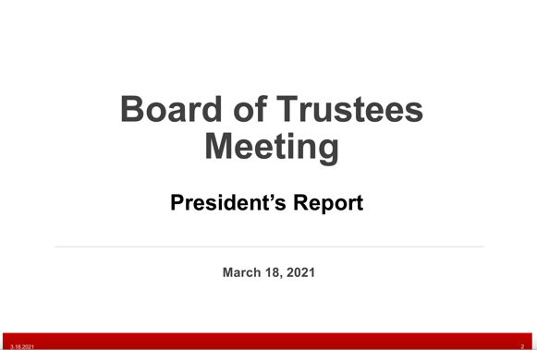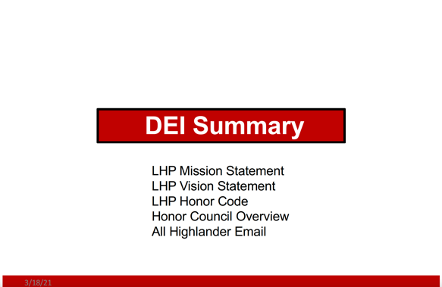

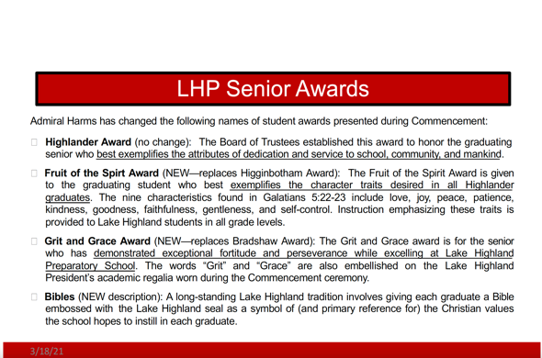

- 1354, 22 March Email from Pres. Harms to BOT Chair/DEI Comm. Co-Chair Deery, BOT Vice -Chair Ramsby, and DEI Co-Chair Lewis

From: Alfred Harms, Jr. [mailto:aharms@lhps.org]
Sent: Monday, March 22, 2021 3:54 PM
To: Jeff Deery - Trustee <JDeery@whww.com>; Derek Lewis - Trustee <derek.lewis@pepsico.com>; Greg
Ramsby <gramsby@drz-inc.com>
Cc: Lynn Math <lmath@lhps.org>
Subject: Dra( email (school history)\\

Dear Jeff, Greg, Derek,
As I mentioned at last week’s BOT meeting, and as part of our DEI initiatives (to counter many misleading rumors regarding our founding as a school), I feel it is necessary to publish a brief email which acknowledges our founding with as many details as practicable, yet presented in a credible and balanced fashion. The attached document has been vetted through the key players of our staff, but before launching to our entire Highlander family at end week, I wanted your review/comments for it will surely raise some eyebrows. FYI, all the info is documented in the various historical sources we reviewed. Thank you for your time/consideration, and I hope to receive your feedback by COB , Wednesday, 24 March.
Have a great rest or the week, and Jeff, I hope your knee is feeling better and therapy is not too onerous.

Warmest regards, AL

- 1718, 22 March email from Ramsby to Harms/Deery/Lewis

From: Greg Ramsby <gramsby@drz-inc.com>
Date: Monday, March 22, 2021 at 5:18 PM
To: Alfred Harms, Jr. <aharms@lhps.org>, Jeff Deery - Trustee <JDeery@whww.com>, Derek Lewis -Trustee <derek.lewis@pepsico.com>
Cc: Lynn Math <lmath@lhps.org>
Subject: RE: Dra( email (school history)

Admiral: I’m not familiar with the “many misleading rumors regarding our founding as a school” you reference below. I assume those must be related to some of the leaders from OJC who stayed on for the founding of LHPS that you reference in your note and which we discussed in the BOT meeting relating to name changes for graduation awards. While these individuals may have “influenced the birth of Lake Highland Preparatory School”, that “influence” has long since passed in my view. We truly have become what we profess to be: “the school of opportunity” Equal opportunity. I like everything about your note but would suggest more emphasis and perhaps some facts on our continued evolution away from such historical “influences”. Perhaps we can say or present more than just providing a link to our DEI initiatives?? More emphasis specifically on the numerous efforts we are making to continue to evolve to be fair to all I think
would be important as our families read this.
Thanks for your attention to such an important matter. Please keep us informed. Greg
- 2149 23 March email from Harms to Ramsby/Deery/Lewis

From: Alfred Harms, Jr. [mailto:aharms@lhps.org]
Sent: Tuesday, March 23, 2021 9:49 PM
To: Greg Ramsby <gramsby@drz-inc.com>; Jeff Deery - Trustee <JDeery@whww.com>; Derek Lewis - Trustee<derek.lewis@pepsico.com>
Cc: Lynn Math <lmath@lhps.org>
Subject: Re: Dra( email (school history)

Dear Greg,
Good evening, and thank you for your timely input. I hear you loud and clear, and I do not completely disagree with your sentiments. In fact, it is a doable option, but I strongly recommend that we not pursue this course of action. I don’t know how large in total numbers, but please know that there is unarguably a segment of our Highlander family (including students, employees, alumni, and parents—all who have communicated with me) who believe LHP’s origination was likely modeled similar to myriad independent schools (segregation academies) all across the country and especially in the south. And frankly speaking, many of these individuals want the school to publicly admit those likely circumstances of our founding. To be sure, neither we (LHP Staff) nor anyone else can be 100% sure of the pure motives of our founders; however, in my view, the preponderance of evidence suggests that “exclusionary/discriminatory” principles were likely a major consideration in our founding. In most situations, I like you, would prefer looking forward and emphasizing our progress/performance as an institution versus dwelling on the past. However, I also believe
that if we cloud/diffuse this singular difficult conversation of our founding with a list of positive
actions/intentions, we will not get full credit for owning up to our past, and risk further suspicion that we are hiding something or yet again avoiding the hard truth. To be sure, we have (and have planned) plenty of future opportunities to share/highlight our initiatives and progress, including targeted messaging and expanding our DEI web presence. That said, I still strongly believe it would be best to bite the bullet now, head on address the uncomfortable issue, and then regularly follow up with positive stories on the DEI initiatives that we have planned and executed. Does that make sense to you? If so, would you back that approach? I’ll also keep you posted as I hear from Jeff and Derek.

THX, AL

- 0655, 24 March email from Ramsby to Harms/Deery/Lewis

Subject: RE: Draft email (school history)
Date: Wednesday, March 24, 2021 at 6:55:48 AM Eastern Daylight Time
From: Greg Ramsby
To: Alfred Harms, Jr., Jeff Deery - Trustee, Derek Lewis - Trustee
CC: Lynn Math

Makes perfect sense Admiral….I totally agree with owning up to our past now/diffuse this situation/address the hard truth…and then use future opportunities to highlight our initiatives and progress….I have a very clear picture now of our approach to dealing with this and you have my 100% support. Have a great day

Greg
- 0936, 24 March email from Deery to Harms/Ramsby/Lewis

Subject: Re: Draft email (school history)
Date: Wednesday, March 24, 2021 at 9:36:29 AM Eastern Daylight Time
From: Jeff Deery
To: Alfred Harms, Jr.
CC: Derek Lewis - Trustee, Greg Ramsby - Trustee, Lynn Math

Thank you for undertaking this Al. I think it’s the right thing to do and the right time to do it. A few suggested edits:
- In the third sentence of paragraph three, start the sentence with “When” and move 1970 to the end. As it reads now, one can become confused as to whether OJ C was segregated from its inception or whether LHP was segregated from its inception, or both.
- To be more accurate, I think you should refer to the emergence of other “publicly funded community colleges…“.
- While embracing integration may have been a factor in the success of other 2 year schools, state funding of junior colleges made OJC obsolete almost overnight.

More to follow.....

- 0945, 24 March email from Deery to Harms/Ramsby/Lewis

Subject: Re: Draft email (school history)
Date: Wednesday, March 24, 2021 at 9:45:12 AM Eastern Daylight Time
From: Jeff Deery
To: Alfred Harms, Jr.
CC: Derek Lewis - Trustee, Greg Ramsby - Trustee, Lynn Math

I suggest that the sentences below become a separate paragraph, beginning with “Although...”
“Although many of the leaders of OJC were responsible for founding LHP, we found no definitive documents that indicated discrimination in either LHP’s establishment, or its inaugural administrative policies and admission processes. Nonetheless, given the mid-century political and cultural climate in America and especially Florida, it seems undeniable that the systemic racism of the time influenced the birth of Lake Highland Preparatory School.”

Also, to be more accurate, I suggest changing the wording to read as follows:
“Although many of the leaders of OJC were responsible for founding LHP, we found no definitive documents that indicated discrimination in LHP’s establishment, its inaugural administrative policies, or its admission processes. Nonetheless, given the mid-century political and cultural climate in America and especially in Florida, it seems undeniable that some parents‘ strong desire to remove their children from segregated public schools influenced the birth of Lake Highland Preparatory School.

